# Software Requirements Specification

**213J15**

**219J05**

1. Introduction:

- Purpose:

- The purpose of the Remote desktop System is to enable remote screen sharing and control between a server and multiple clients.

- Scope:

- The system will capture the screen from the server and transmit it to connected clients.

- Clients can send keyboard and mouse events to control the server.

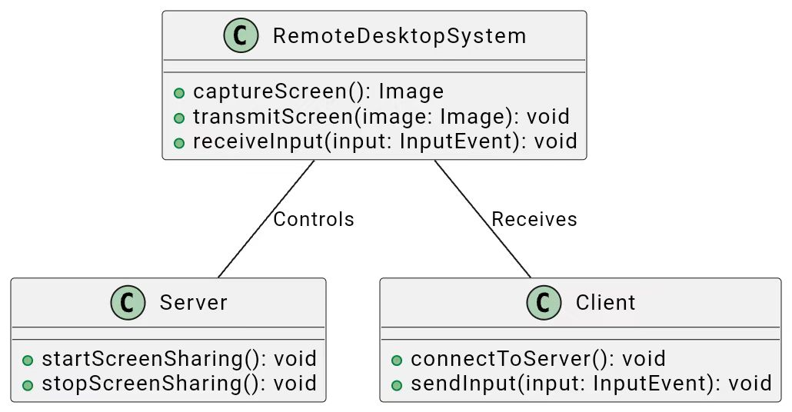

2. Functional Requirements:

- 2.1 Screen Sharing:

- The system shall capture the server screen at regular intervals.

- The server shall compress the captured screen image.

- The server shall transmit compressed images to connected clients upon request.

- 2.2 User Input:

- Clients shall be able to send keyboard and mouse events to the server.

- Server shall interpret received input and simulate corresponding actions.

- 2.3 Compression:

- The system shall utilize Snappy compression for screen images.

- 2.4 Server Control:

- The server shall be capable of starting and stopping screen sharing.

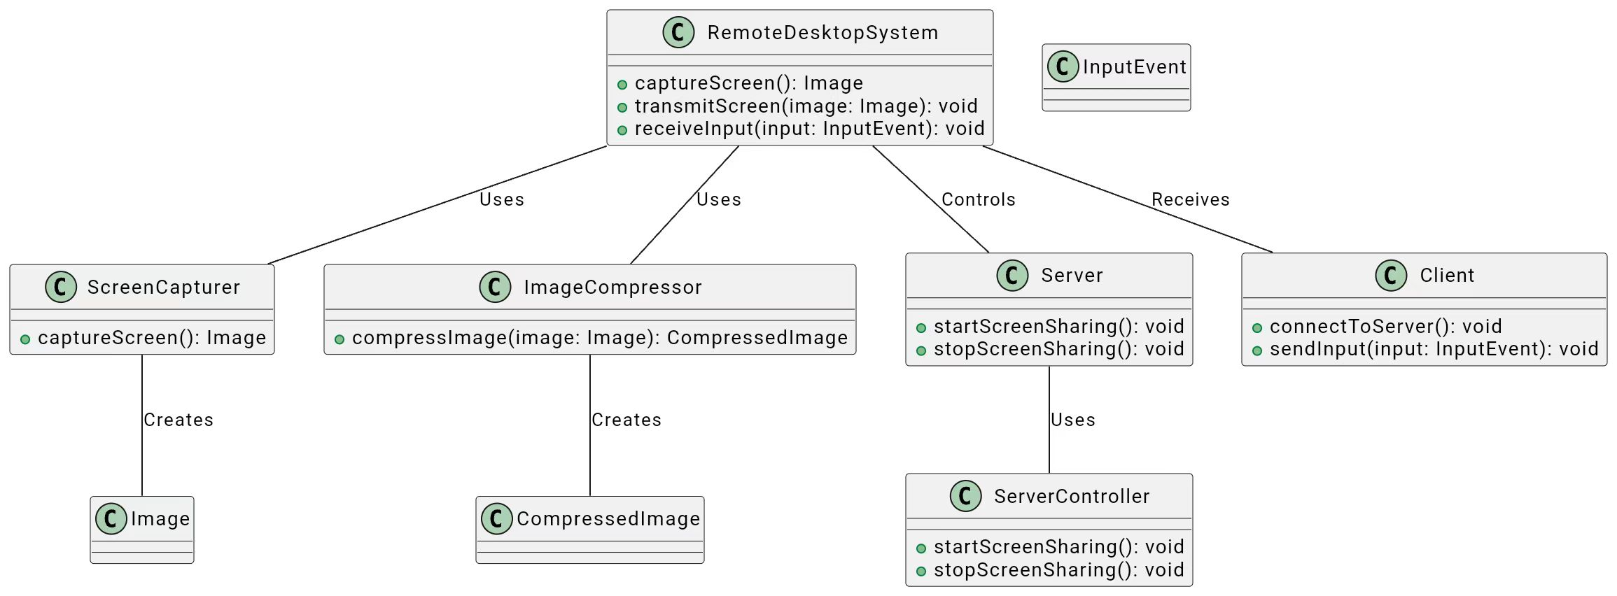

3. Non-Functional Requirements:

- 3.1 Performance:

- The system shall capture and transmit screen updates with minimal latency.

- Compression and decompression processes shall be optimized for efficient performance.

- 3.2 Security:

- Communication between the server and clients shall be encrypted.

- The system shall implement user authentication for server access.

- 3.3 Reliability:

- The system shall handle disconnections and reconnections gracefully.

- Error messages shall be clear and informative.

- 3.4 Scalability:

- The system shall support multiple concurrent clients.

- 3.5 Usability:

- The user interfaces for the server and clients shall be user-friendly.

- Logging and debugging information shall be accessible for troubleshooting.

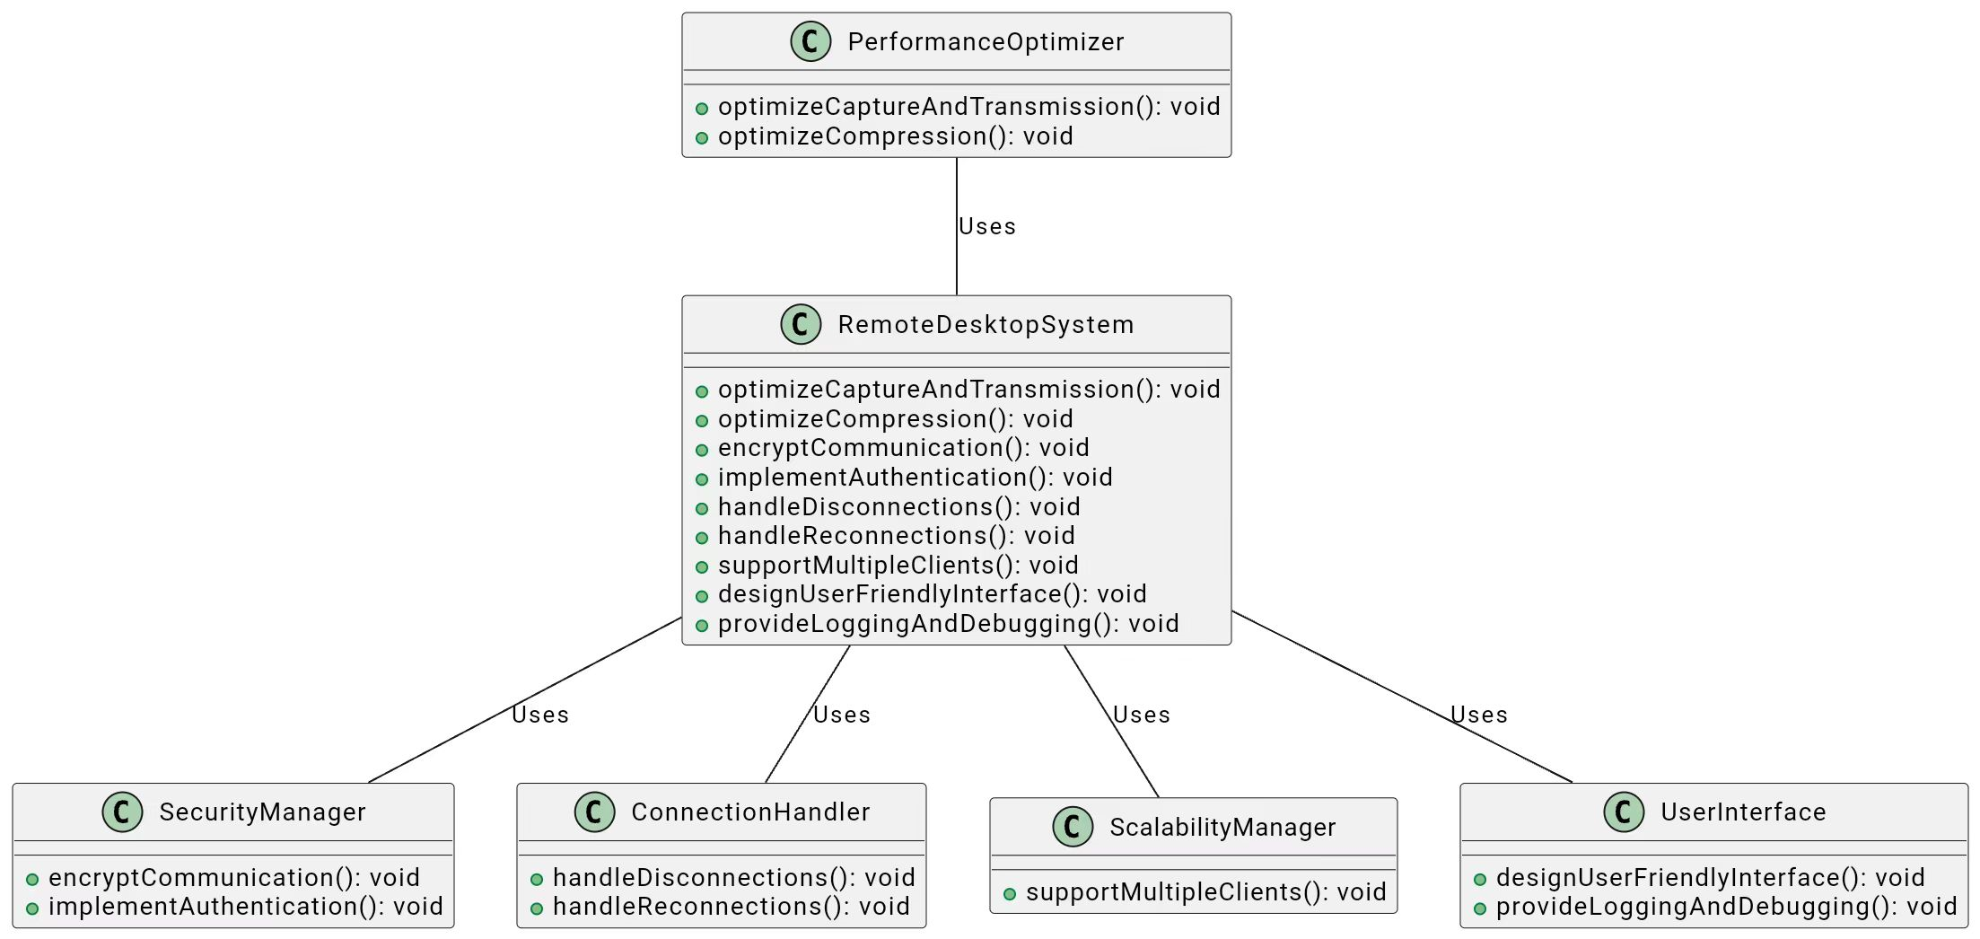

4. External Interfaces:

- 4.1 User Interfaces:

- The server shall provide a simple graphical interface for starting and stopping the screen sharing.

- Clients shall have an interface for connecting to the server and interacting with the remote screen.

- 4.2 API:

- Define the communication protocol used for interactions between the server and clients.

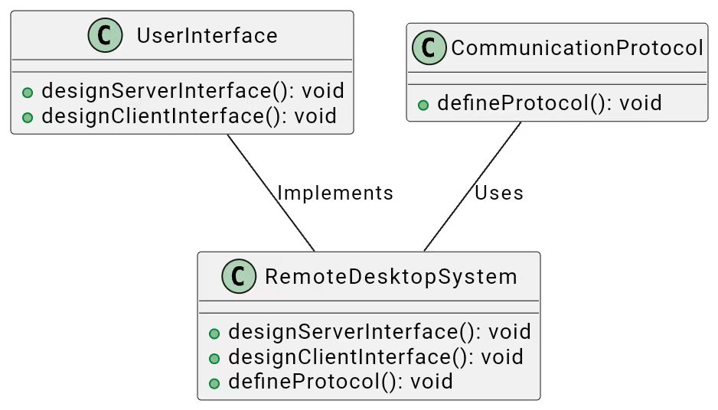

5. Constraints:

- The system is constrained by the limitations of the Java Robot class for capturing the screen.

- Compatibility with the operating system APIs for keyboard and mouse events.

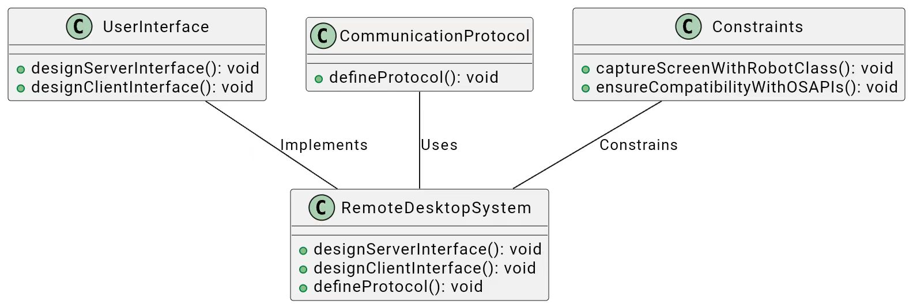

6. Testing Requirements:

- 6.1 Unit Testing:

- Test individual components, including screen capturing, compression, and input handling.

- 6.2 Integration Testing:

- Verify the interaction between server and client components.

- 6.3 Performance Testing:

- Evaluate the system's performance under various loads.

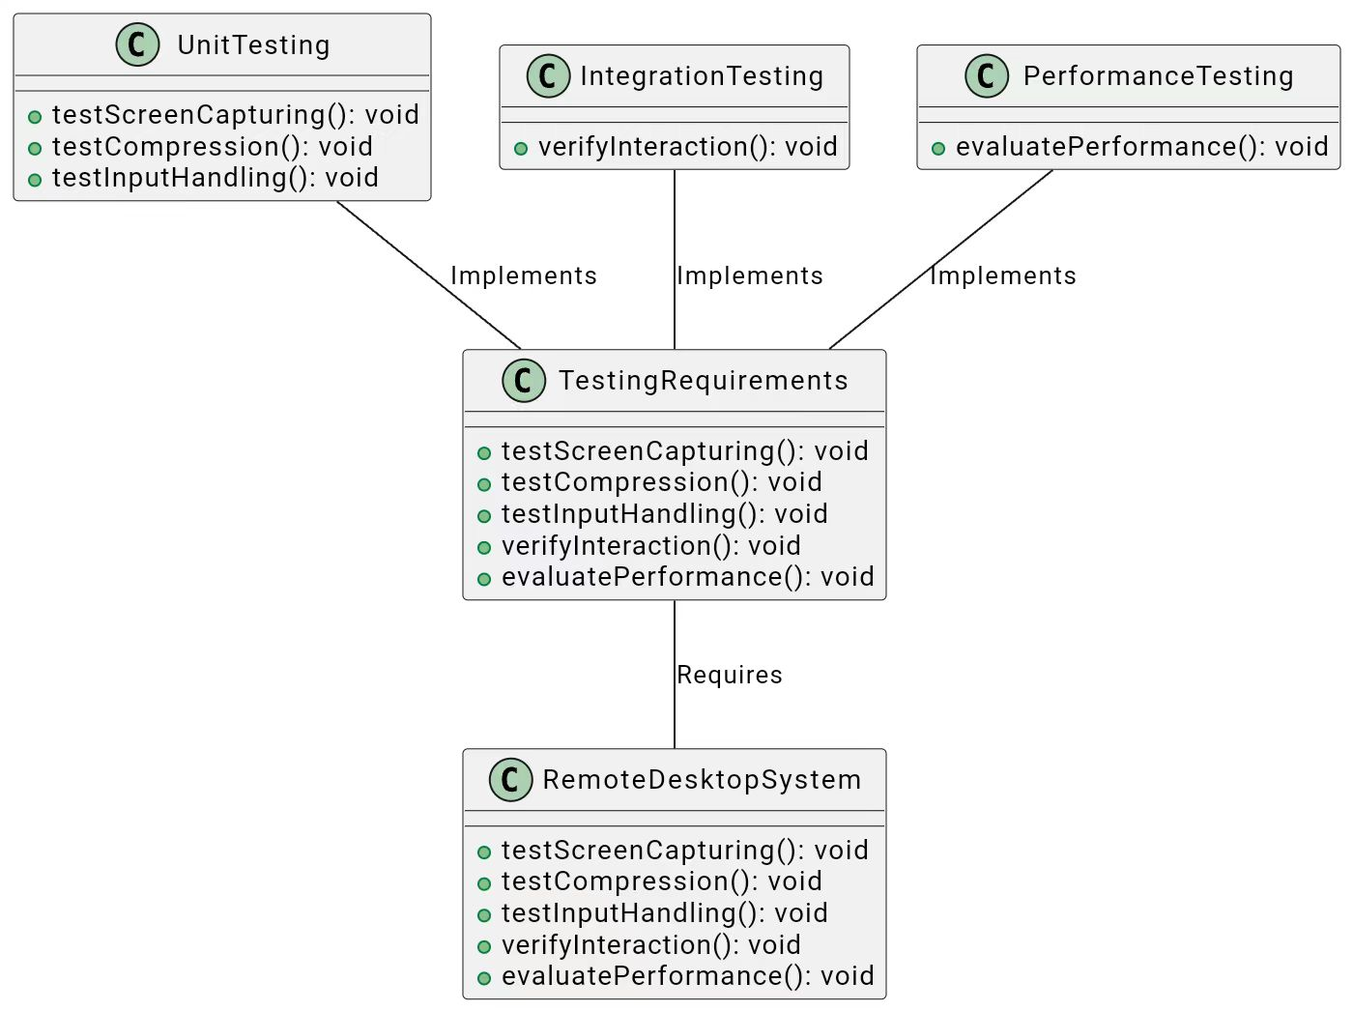

7. Documentation Requirements:

- Comprehensive code documentation.

- User manuals for both the server and client applications.

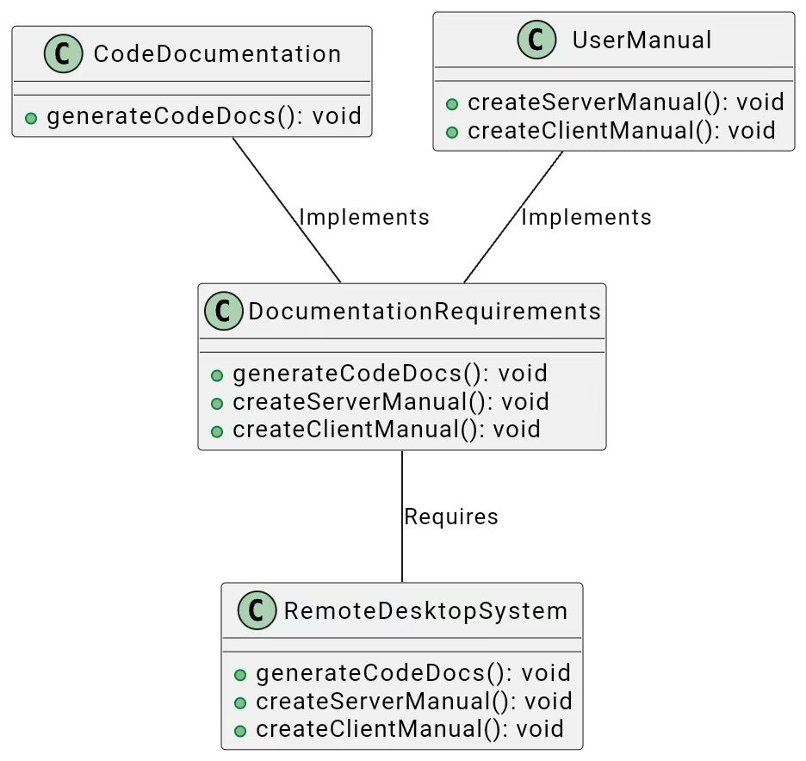

# Class Diagram: Remote Desktop System

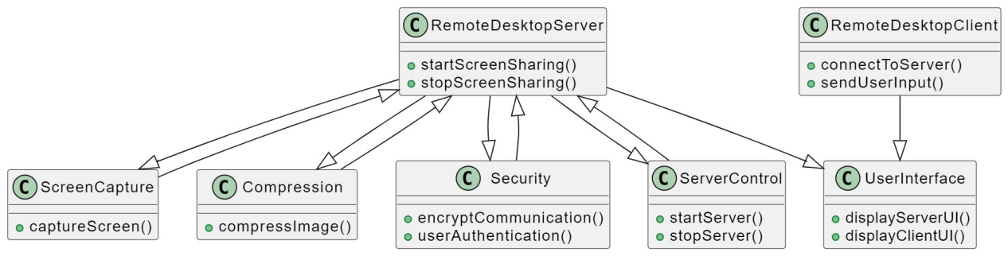

# Sequence Diagram: User Interaction with Remote Desktop System

